1. **The Finalized Topic of your Project**

My Project topic is FollowMe

1. **What is Stakeholder Analysis? And Who are the Stakeholders of your Project?**

First just a definition of project stakeholders. A Stakeholder is either an Individual, Group or Organization who is impacted by the outcome of a Project. They have an interest in the Success of the Project. And can be within or outside the Organization that is Sponsoring the Project.

A Stakeholder Analysis is a process of identifying these People before the Project begins. Grouping them according to their levels of participation, interest and influence in the Project and determining how best to involve and communicate each of these Stakeholder Groups through. Stakeholder Analysis is an important technique for Stakeholder Identification and Analyzing their needs.

Owners / Shareholders:

The project’s financer.

Steering Committee:

An advisory group providing guidance on key decisions, which includes the sponsor, executives, and key stakeholders from the organization.

Business Partners:

external organizations that have a special relationship with the enterprise

Staff:

The Users who will approve and manage the project’s service or result

Competitors:

Competitors are other Companies with close and unique Services and Products

1. **Why Stakeholder Analysis Is important?**

Being able to identify and categorize the Stakeholders involved in your project helps you prioritize input, manage feedback and stay during the course of the Project. The above matrix is used to identify the right information to the right person to make an effective communication. If we don’t get Stakeholder Analysis right the Project may not be successful and reduce Productivity.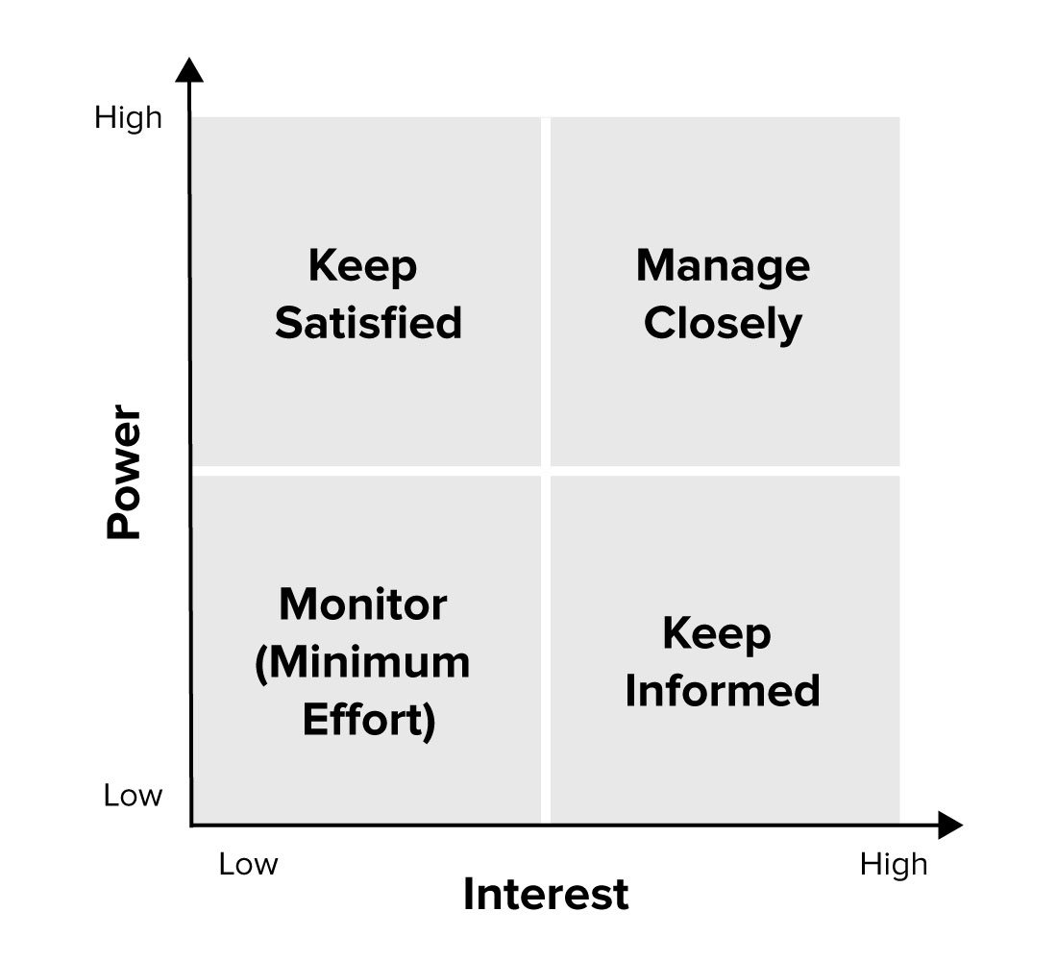

1. **When to use Stakeholder Analysis?**

Stakeholder Analysis should do before starting the Project and during the Requirement Analyzing

1. **Stakeholder Analysis for your Selected Project**

* Owner / Sponsor : Creating an environment leading to successful projects. Completion time and final costs are within prescribed limits and tolerance or eliminate lengthy delays.
* Team Members : To ensure the work is done according to the prepared plan and standard quality to meet the missing statement that were been set by the managers and the management board.
* Steering Committee : An advisory group providing guidance on key decisions, which includes the sponsor, executives, and key stakeholders from the organization.
* Executives : The top management in the Company executing the project those who direct the organization’s strategy.
* Competitors : Competitors are other Companies with close and unique Services and Products.
* Staff : The Users who will approve and manage the project’s service or result

| Keep Satisfied  Staff  Executive | Manage Closely  Sponsors  Owners  Steering Committee |
| --- | --- |
| Monitor  Competitors | Keep Informed  Team Members |